CHEMICAL, ELECTROCHEMICAL AND COMPUTER SIMULATED CONCEPT OF 2-HEPTANONE AND 2-TRIDECENE AS CORROSION CONTROL FOR MILD STEEL IN ACIDIC MEDIA.

Abstract
Gravimetric and electrochemical methods were utilized to examine the performance of dacryodes edulis seed extract (DESE) as anti corrosion agents for mild steel in HCL and H₂SO₄ solutions .The results generated from gravimetric technique show that inhibition efficiencies (IE) raised as the concentration of the extract increases. Potentiodynamic Polarization Parameters show that DESE acts as a mixed type inhibitor. The values obtained from active capacitance by using electrochemical impedance parameters in the two acidic media are within the thresh hold of double layer capacitance. The anti corrosion efficiency was evidenced by the adsorption of the DESE components on the surface of mild steel which was approximated by Langmuir adsorption isotherm model. The mechanism of the corrosion inhibition was evaluated from the temperature and concentration reliance of the inhibition efficiencies, in addition to the spectroscopic results. RSM results established an optimal IE of 97.5 % and 93.20 % at ideal concentrations of 1.2 gl⁻¹,temperature of 303k and time of 12h for both media. The theoretical modeling shows that 2-heptanone and 2-tridecene were the major bioactive constituents of dacryodes edulis seed extract accounting for the inhibition hindrance process. Furthermore, scanning electron microscope analysis confirmed adsorption of the extract molecules on the surface of the mild steel.
Key words; Mild steel; Corrosion; 2-Tridecene; 2-Heptanone;Impedance; Density functional theory; Response surface methodology.

Introduction
Mild steels are regularly used for various ranges of applications in industries and installations as a result of their excellent mechanical properties and affordable costs compares with many other metallic materials [1]. But the weak corrosion resistance of mild steel in acid medium is a great impediment to its indispensable applications [2]. The use of inhibitors in eradicating its corrosion processes have shown to be very effective and most suitable [3]. Unfortunately, a large portion of the synthetic compounds that constitutes these inhibitors are very expensive, toxic to human, and environmentally unfriendly [4]. The cost implication of these inhibitors , the toxicity and eco-unfriendly nature of both organic and inorganic inhibitors have given way for researchers to explore the potential use of non-toxic , cheap and biodegradable natural inhibitors that are environmentally accommodating [5-8]. The application of some plants extract in the protection of mild steel corrosion in aggressive environment such as HCL and H₂SO₄ has been reported in the literature; Armorracia rusticana was used as sustainable and eco-friendly corrosion inhibitor for mild steel in 0.5 M H₂SO₄ with IE 95.74 % and concentration of 100 mgl⁻¹ [9], salvia officinalis indicates 96 % corrosion hindrance at concentration of 2500 mgl⁻¹ [10], Osmanthus fragans revealed 94 % inhibition efficiency at 340 mgl⁻¹ [11], Tannins extracted from Mangrove,shows 89 % IE at 600 ^{mg-l} [12], Musaparadisiaca extract unveiled IE of 90 % at 300 mgl⁻¹ [13], At 120 mgl^{-l} of Jasminum nudifloruum extract concentration ,92 % IE was indicated [14], Kola nitida indicates 78 % IE at 1200 mgl⁻¹ [15} , Root extract of Raddish shows corrosion hindrance of 79 % at 1000 mgl⁻¹ [16], Picralima nitida leave shows 88.54 % IE at 1.2gl⁻¹ [17], Akuamma seed indicates 72.6 % IE at 1.2gl⁻¹ for aluminum in 1.0 M HCI environment [18], Muraya koenigi root shows restraint effectiveness of 96 % at 600 mgl⁻¹ [19] and Butea monosperma revealed 98 % IE at 500 mgl⁻¹ [20]. Dacryodes edulis is a fruit tree origin to Africa. Sometimes called bush pear, butter fruit or plum [21]. It belongs to the family of burserasea, and are grown in a wide variety of climates and soil type [22]. The fruit of this highly regarded agricultural produce is yellowish and some pinkish in color. They turned bluish dark in color when ripped [23]. The pulps are edible while the seed are discarded due to its non-edibility [24] The outstanding features of the seed extract are its ability to contain considerable quantity of anti-nutrients such as phenolics, terpeniods and tannins. In addition, saponins , flavonoids and alkaloids are contained in moderate amount . Indubitably, the dacryodes edulis seeds being discarded agricultural products have been reported to be valuable sources of 2-heptanone and 2-tridecene [25]. The chemical structures of the components are shown in figure (1). The potentials of the DE have been explored in the field of food industry, pharmaceutical, biodiesel, and cosmetics industries (soap, perfume, creams) as well as in other branches of industry where fat raw materials are needed [26-28]. These phyto-compounds contain hetero atoms (N, O, S) and aromatic ring which are assumed to be active centers of adsorption. Hence the seed extracts obtained from the DE can function as a valuable anti-corrosion material for mild steel. There are some reports on the use of Dacryodes edulis parts as corrosion inhibitors for metals in some aggressive environments. For example, Dacryodes edulis extract has been used as corrosion inhibitor for low-carbon-steel in acidic media [29]. Inevitably, and to the best of our knowledge, little or no report of the application of gravimetric method using Central composite design (CCD) via response surface quadratic model and quantum computational techniques have been carried out on the dacryodes edulis seed extract in mild steel subjected to acidic media.
The present research continues to aim at the application of 2-heptanone and 2-tridecene, which are major components of dacryodes edulis seed extract (DESE) for mild steel (1005AISI Grade) corrosion protection using chemical, electrochemical, and computer simulated techniques. Fourier transform infrared (FTIR) and GCMS were further deployed to examine the chemical functional groups and identify the major compounds in DESE. Furthermore, modeling via the use of response surface methodology (RSM) is important for the optimization of anti-corrosion effectiveness. This method involves the application of mathematical and statistical codes for modeling, optimization and regression in complex corrosive interaction of process variables [30]. Furthermore, quantum chemical computation method was employed in order to establish the effect and special roles played by the individual molecules in DESE. It involves the integration of the experimental values and theoretical dynamic simulation techniques using density functional theory (DFT) [31]

Figure 1 (a) 2-tridecene (b) 2-heptanone

2. Experimental

2.1. Test metals preparation

Mild steel sheet with the composition of (wt %) : Fe 99.ss07% , P 0.01%, Mn 0.85%, Si 0.02%, S 0.02%, Cu 0.02%, C 0.23%, Ni 0.01% and Cr 0.02% was squeezed-cut into coupons of measurements 2.6 x 2.6 x 0.15 cm. The metals were abraded using emery papers of (400 - 1200 grit).The specimens were degreased with absolute ethanol, rinsed with deionised water to remove dirt. The abraded metal coupons were further dried in acetone ((CH₃)₂CO) and placed away in air- free desiccators preceding use [32]. For potentiodynamic polarization and electrochemical impedance spectroscope techniques, the specimens were utilized as the working electrodes and 1 cm² of the uncovered surface zone was effectively used.
2.2. Preparation of inhibitors from plant extract

Dacryodes edulis seeds were gathered from Uke in Anambra State, Nigeria. Identiffication of the seed was done by taxonomist from the Department of Agriculture, Chukwuemeka Odumegwu Ojukwu University, Anambra State, Nigeria. The fresh seeds of DE were first washed to expel dust particles and later sun - dried for 8 days before ground to powder form with the aid of electric blender. Precisely 30 g of sieved damp – free dacryodes edulis seed powder were measured and introduced in 1000 ml of absolute ethanol for time of 48 h. The extract obtained in ethanol solvent was concentrated to dryness, weighed and kept in the desiccators for further use. The methodology embraced here has similarity with that revealed by different analysts [33-36].The stock solution of the DES extract was phytochemically analysed using uv-visibly to ascertain the presence of tannins,saponins,flavonoids,steroids,phenolics and alkaloids. The reagents,

H₂S0₄ (98%), HCl (98%), acetone (98.6%) and absolute ethanol (98%), were all of A-R grade procured from Baker, Germany.

2.2.1. FT-IR analysis of Dacryodes edulis seed extract

The metal samples were immersed in the acid media in the absence and presence of the plant extracts. At the end of the corrosion study, the corrosion products in the beakers were collected, characterized by SHIMADZU FT-IR spectrophotometer, model: IR affinity – 1, 5/NA 2137470136 SI utilizing KBr powder method in the range of 1300-4000 cm⁻¹ for the determination of the functional groups and chemical bond of the pure extract and corrosion products. Comparative analysis of various FTIR produced peaks were carried out in order to determine the shifting mechanism for the corrosion inhibition process.
2.2.2. GC-MS analysis of DES extract
GC-MS analysis was carried out on DESE. Gas chromatograph-mass spectrophotometer, Model No QP2010 plus Shimadzu, Japan. The carrier gas used was Helium at a flow rate of 0.5ml/minute inlet temperature was maintained at 250°C while the oven temperature was programmed initially at 80°C for 4 min in order to stabilize. The temperature range was later increased to 240°C and finally subjected to 280°C at a total run time of 90 minutes. The mass spectrometry transfer line was maintained at a temperature of 200°C while the source temperature was stationed at 180°C. The peaks in the chromatogram were integrated and compared with the database of GC-MS spectrum stored in the (NIST05 library).

2.3. Weight loss method

Weight loss measurements of already weighed mild steel specimens were performed for 24hs at 303, 313 and 323k respectively in blank solutions of 0.5M H₂S0₄ and 1.0 M HCl individually and in the presence of 0.2, 0.45, 0.7, 0.95 and 1.2gl⁻¹DESE. At the end of corrosion analysis as earlier reported [41], the specimens were removed, immersed in acetone, scrubbed with a bristle brush under running water, dried and reweighed using electronic balance. The differences in the weight of the specimens were recorded on table 2 and 3
The obtained data were properly recorded on table 2 and 3 and evaluated using eqns. (1)–(4) respectively as reported in the literature by [37]
ΔW = W_{i}–W_{f} (1)
$$CR = \frac{W_{i}{- W}_{f}}{At} (2)$$
$$IE\% = \frac{W_{o}{- W}_{1}}{W_{o}} x 100 (3)$$
$$θ = \frac{W_{o}{- W}_{1}}{W_{o}} (4)$$
Where W_{i} and W_{f} are the initial and final weight of mild steel (g) respectively. W_{o} and W_{I} are the weight loss (g), in absence and presence of inhibitors, respectively. A is the surface area (cm²) of mild steel, CR is the corrosion rate (mm year⁻¹) and t is the immersion time (h).

2.4. Electrochemical techniques

For potentiodynamic polarization (PDP) and electrochemical impedance spectroscopy (EIS), test metal specimens of mild steel for electrochemical measurements were molded into round and hollow specimens and fixed in polytetrafluoroethylene (PTFE) poles utilizing epoxy resin in a way that uncovered only a single surface area of 1cm² to the inhibited and acidic media. The cathodes utilized were cleaned, washed with double deionized water, degreased with ethanol and dried in acetone. The electrochemical investigations were directed in a three terminal corrosion cell applying a versa stat 400 complete dc voltammeter and corrosion system with V3 studio programming for electrochemical impedance spectroscopy and potentiodynamic/Galvanostat 263 system workstation with E-chem. programming for PDP tests. A platinum sheet was used as counter electrode and a soaked calomel electrode (SCE) as reference terminal complimented the potentiodynamic polarization. The calomel electrode was associated through a carrying slender while mild steel coupons were used as working electrode. PDP curves were completed between the cathodic potential scopes of - 2.5 V with regard to open circuit potential (OCP) and proceeding up to an anodic capability of 2.5 V vs.SCE at an output rate of 0.5 mVs⁻¹. Impedance estimations were completed in an unhindered and circulated air toward finish time of 30 min and temperature of 305 k using digital water bath. The EIS estimations were performed when the corrosion potentials (Ecorr) was kept between frequency range of 100 kHZ-1mHZ and a perturbation of 5mV neck-to-neck sinusoidal wave [38]. All the corrosion tests were performed in triplicate to validate the reproducibility of the average experimental measurements. The whole corrosion investigations were completed utilizing new samples relentlessly kept up at a temperature of 305 k in a computerized indoor regulator [39].
For PDP, the values of inhibition efficiencies were deduced from eqn. (5)
ɳ (%) = $\frac{\begin{aligned}– \\ Icorr,o-Icorr\end{aligned}}{Icorr,o }$x 100 (5)
Where I_{corr,o} and I_{corr} represent the current densities of the uninhibited and inhibited working electrodes, respectively.

The EIS data were fitted and properly analyzed using Zsampwin. The inhibition efficiencies (ɳ) obtained from EIS tests were evaluated from eqn. (6).

ɳ (%) = $\frac{Rct-Rcto}{Rct}$ x 100 (6)

Where R_{ct} and R_{cto} are the charges transfer resistances of the working electrode in the presence and absence of DES extract respectively.
carry out
2.5. Quantum chemical investigations

Quantum chemical computation technique was employed to carry out molecular simulation of the major components of DESE; 2-heptanone and 2tridecene. The parameters for these two key components were computed and listed on table ( ). Using DFT calculation with the application of electronic structure program Dmol³ via mulliken population measurement [40]. For core electrons at the ground atomic orbital state, the DFT semicore pseudopotentials (DSPP) was employed [41]. These techniques model the corrodents as a depth of heterogenous dielectric constant, and the solute was introduced in the hollow within it. The self – consistent field (SCF) method was employed with a convergence of 10⁻⁵ and a Femi swearing value of 0.005 Hartree to raise the rate of SCF convergence. Consequently, the geometry optimization was arrived at using the compass force field and smart minimization techniques. Quantum chemical parameters like, E_{HOMO}, E_{LUMO}, the energy gap ∆E (E_{LUNO}-E_{HOMO}), and adsorption energy were secured for the extract molecules of 2-heptanone and 2-tridecene to facilitate the prediction of its reactive interaction toward the mild steel surface.

3.0 Results and discussion

Table 1: FT- IR analysis on the shifting mechanism of DES extract
Dacryodes edulis seed extract corrosion product of mild steel in 0.5 M HCL with 1.2 gl⁻¹ of DES extract
Peak (cm⁻¹) Assignments Peak (cm⁻¹) Assignments
3971.7 - 3539.38 Free bond of alcohol 3948.54 - 3508.5 O-H free alcohols
3477.62 - 3354.1 N-H stretch of amine 3373.4 - 3292.34 N-H amine
3261.46 ΞC-H bond of alkyne 3137.94 - 3018.28 C-H (aromatic)
3172.68 - 2925.64 C-H , alkynes, aromatic 2952.66 -2516.48 O-H, carboxylic
2798.26 - 2582.1 O-H, free bond of alcohol 2416.12-2064.84 CΞC or CΞ N,alkynes
2493.32 - 221.54 CΞN, stretch of alkynes 1937.48-1752.2 C꞊O stretch of acids,
2133.76 - 2030.12 CΞC stretch of alkynes 1659.56 C+C benzene ring
1902.74- 1659.56 C-O, stretch of acids, esters, 1597.8-1536.04 C꞊C benzene ring
1566.92 N-H bond of amines and 1377.78 C-H bonding methyl
1497.44 to 1319.24 C-H stretch of alkyl bonding groups 1289-1130.74 -O-R aromatic

Figure 2. FT-IR of dacryodes edulis seed extract (pure).

Figure 3. FT-IR of dacryodes edulis seed extract (corrosion product).

3.1. GC-MS analysis of dacryodes edulis seed extract
Examination of different intermediates energy peaks of GC-MS in fig.4 indicate that, Peak 1 demonstrates 1,3-dixolane-4-methanol,formula C₆H₁₂O₃, mol. weight 132, crest 2 speak to 2-Heptanone, formula C₈H₁₆O, mol. weight 128, Peak 3 was allotted to 2-tridecene, formula C₁₃H₂₆ mol. weight 182, crest 4 speak to tetradecene, formula C₁₄H₂₈ mol. weight 196, top 5 shows phenol, equation C₁₄H₂₂O, mol. weight 206, crest 6 shows 1-hexadecene, formula C₁₆H₃₂, mol. weight 224, pinnacle 7 shows 1-hexadecene, formula C₁₆H₃₂ mol. weight 224, top relegated to hexadecanoic corrosive, formula C₁₇H₃₄O₂, mol. weight 270 pinnacle 9 indicate n-hexadecanoic corrosive, formula C₁₆H₃₂O2, mol. weight 256, crest 10 appointed to cyclopropane carboxylic corrosive, formula C₁₂H₂₀C₁₂O₃, mol. weight 390, crest 11 indicates permethrine, formula C₂₁H₂₀C₁₂O₃ mol. weight 390.
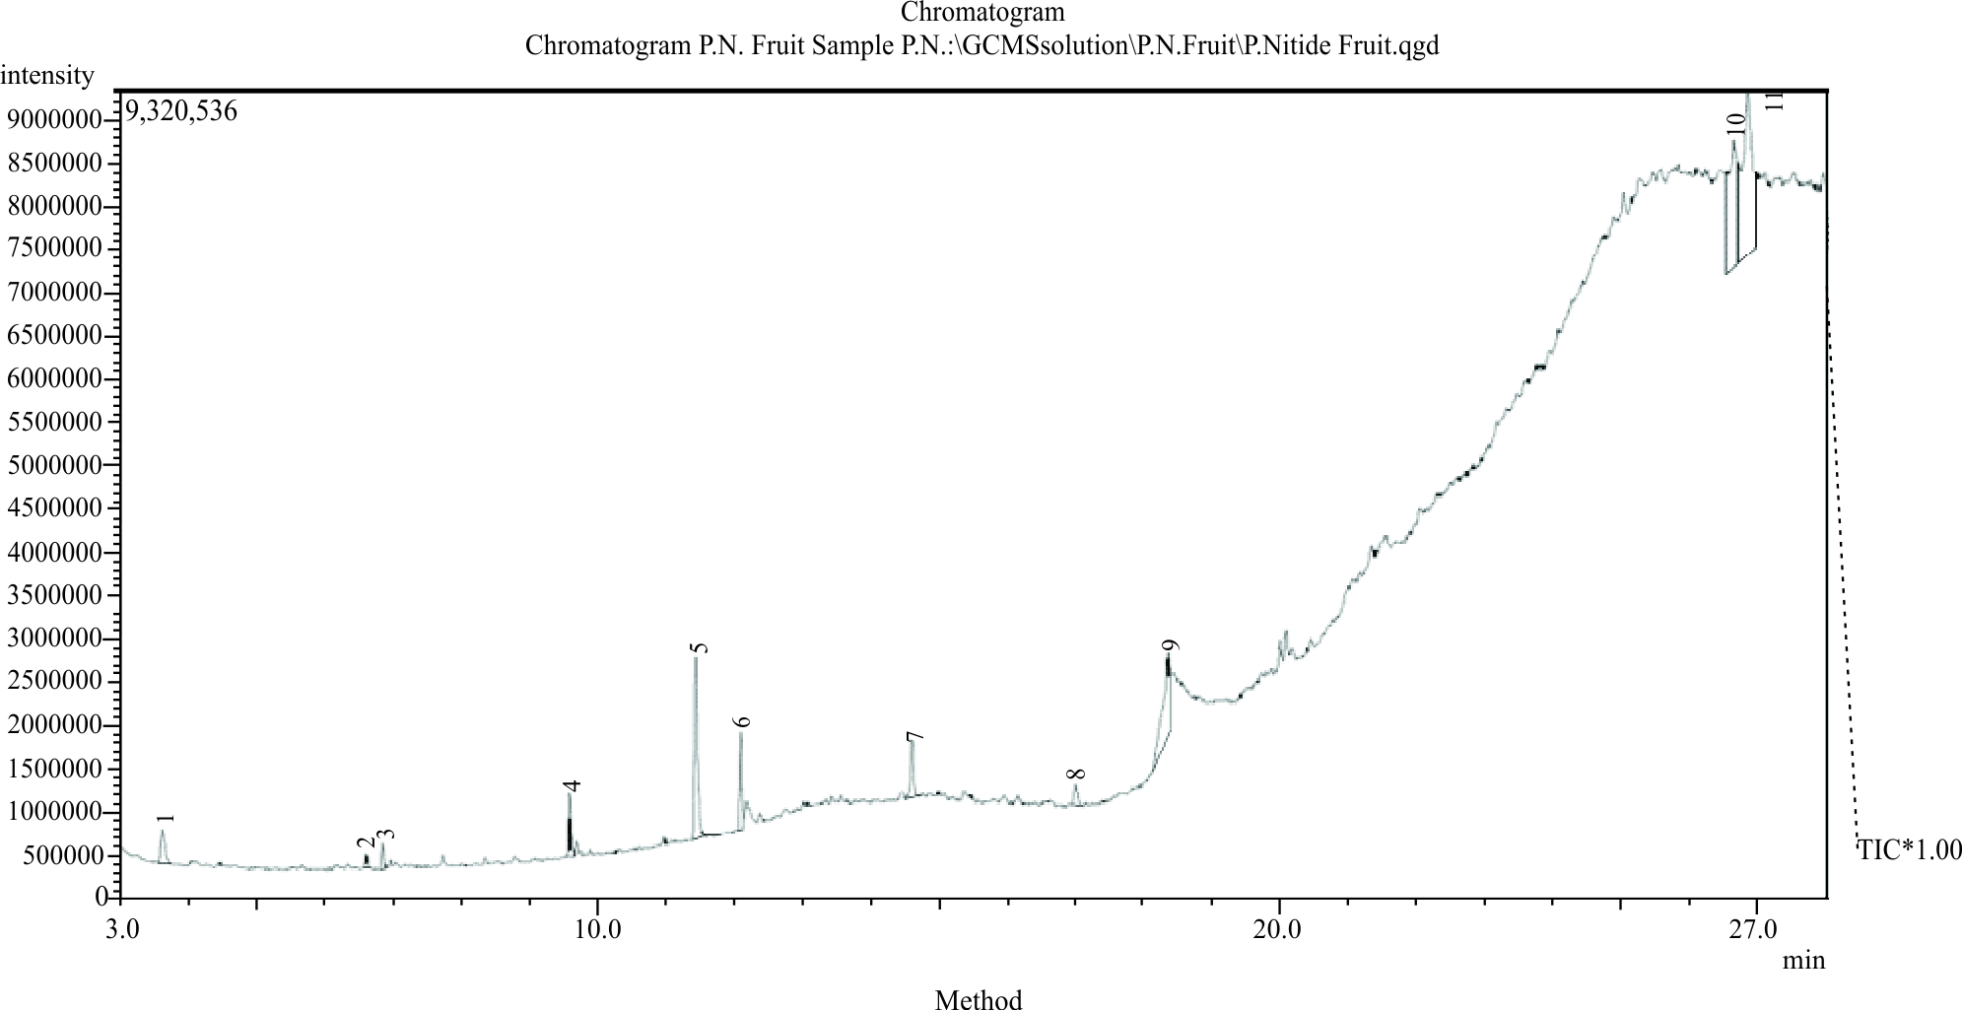
Figure 4.GC-MS spectra of DE seed extract

3.2. Weight loss measurements

Table 2 and table 3 show the results of weight loss method of measuring corrosion rate of mild steel in 1.0 M HCl and 0.5 M H₂SO₄ solutions, which is the oldest technique in history and is still being invoke because of its simplicity. The measurements were done in triplicate and average of the three taken in order to ascertain the authenticity of accurate results. Weight loss method has the advantage of ensuring that the tested inhibitors dissolve in the desired environment. From the results, it was observed that DES proofs to be a strong corrosion inhibitor for mild steel in acidic media. The corrosion rate of mild steel was found to decrease drastically on application of the plant extract. It was further established that mild steel dissolution increased as the temperature of the system increases. The optimal corrosion hindrance was noted at the temperature range of 303K. The observation that the increase in plant extract concentrations increases the inhibition performance can be attributed to the obvious identified anti-corrosion properties of DESE.

Table 2. Calculated results of corrosion rate and inhibition efficiency and surface coverage for mild steel in 1.0 M HCl with and without different concentrations of dacryodis edulis seed extract at 303 – 323k for 24 hs
T (k) IC (gl⁻¹) C_{R} (mm year⁻¹) IE (%) SC (θ)
303 0 2.194 - -
0.20 1.093 50.21 0.5021
0.45 1.019 53.39 0.5339
0.70 0.741 66.24 0.6624
0.95 0.593 73.06 0.7306
1.20 0.556 74.68 0.7468
313 0 2.231 - -
0.20 1.269 43.15 0.4315
0.45 1.102 50.62 0.5062
0.70 0.907 59.34 0.5934
0.95 0.824 63.07 0.6307
1.20 0.741 66.8 0.668
323 0 2.296 - -
0.20 1.398 39.11 0.3911
0.45 1.269 44.76 0.4476
0.70 1 56.45 0.5645
0.95 0.907 60.48 0.6048
1.20 0.898 60.89 0.6089

Table 3. Calculated results of corrosion rate and inhibition efficiency for mild steel in 0.5 M H₂SO₄ with and without different concentrations of dacryodis edulis seed extract at 303 – 323k for 24 hs.
T(k) IC(gl⁻¹) CR(mmyear⁻¹) IE (%) SC(θ)
303 0 18.49 - -
0.20 9.861 46.67 0.4667
0.45 7.444 59.74 0.5974
0.70 5.139 72.21 0.7221
0.95 4.528 75.51 0.7551
1.20 3.741 79.77 0.7977
313 0 18.51 - -
0.20 12.74 31.17 0.3117
0.45 11.3 38.97 0.3897
0.70 7.315 60.48 0.6048
0.95 5.25 71.64 0.7164
1.20 4.852 73.79 0.7379
323 0 18.61 - -
0.20 12.83 31.04 0.3104
0.45 11.39 38.81 0.3881
0.70 8.028 56.87 0.5687
0.95 6.463 65.27 0.6527
1.20 6.519 64.98 0.6498

- (b)

Fig.5. Plot of Langmuir isotherm for mild steel in (a) 1.0 M HCl with DES extract and (b) mild steel in
0.5MH₂SO₄ with DES extract

3.3. Adsorption mechanism.

The corrosion process is electrochemical phenomena, the anodic and cathodic responses being separately oxidation of the metal and reduction of hydrogen molecules. For mild steel in sulphuric acid and hydrochloric acid corrosion, the general response brought about disintegration of the metal and development of Iron sulfate and chloride with respect to the existing conditions:

SO₂ + ½ O₂ →SO₃ ₍₇₎
SO₃ + H₂O → H₂SO₄ ₍₈₎

(In gaseous state above 200ºC)

2Fe + 3H₂SO₄ → Fe₂ (SO₄)₃ + 3H₂ ₍ ₉₎

anodic reactions (noticeable in the presence of oxygen) is given by:

Fe →F²⁺ + 2e⁻ (10)

cathodic reaction:

O₂ + 2H₂O + 4e⁻ → 4OH⁻ (11)
2H₂O + 2e⁻ → H₂ + 2OH (12)

Uniform corrosion was seen when the corrosive secured the whole metallic part [42], confined corrosion when there was buildup of corrosive beads on the surface of the metal [43]. For metals obtained by the development of a layer of metal sulfate/chloride molecules, genuine corrosion will happen if this layer is weakened [44]. The rate of corrosion is expanded by the nearness of corrosive media for example, chlorine and oxidizing specialists (O₂, F³⁺, Cu²⁺) in fluid or Sulphuric solutions.
The most utilized isotherm for the study of corrosion hindrance is Langmuir adsorption isotherm, shown in fig. 5 (a) and (b). The foundation of adsorption isotherms that portray the adsorption of organic molecules can give critical insight to the idea of the metal/inhibitor interaction. It is commonly realized that estimations of Gibbs free energy of adsorption (∆G_{ads}) up to - 20 kjmol⁻¹is steady with electrostatic connection between the charged molecules and the charged metal (physisorption), while those within the region of - 40 kjmol⁻¹ or higher are related with chemisorptions because of sharing or transfer of electrons from the extract molecules to the mild steel surfaces in order to shape a facilitated sort of bond [45] In order to obtain the adsorption isotherm, the degree of surface coverage (θ) for various concentrations of the inhibitor has been calculated according to equation (7) as previously asserted [46].

θ = $\frac{Inh-Unh}{Inh}$ (13)
Where inh and unh denote inhibited and uninhibited corrosion respectively.
In this study, Langmuir isotherm is used to test for the corrosion inhibition ability of DES extract on mild steel via the application of two temperature ranges of: 303 k, and 323 k.

Log C/θ = log C – log K (14)

Where θ is the degree of surface coverage, K is the equilibrium constant of the adsorption isotherm, C is the concentration of the inhibitor in the bulk solution. The linear correlation coefficient is close to unity table 4 [47], hence, adsorption of inhibitor follows Langmuir adsorption isotherms. R² values are in the range as shown in fig. 1 and fig. 2.The adsorption isotherms are strictly based on the assumption that each active site of the metal surface holds one adsorbed species [48]Therefore, one adsorbed water molecule is replaced by one molecule of the inhibitor (DES extract) adsorbed on the surface of mild steel [49]. The apparent free energy of adsorption (ΔGº_{ads}) was calculated from the equation;

ΔGº_{ads} = -2.303 RT log 55.5 K_{ads} (15)

From the eqn., k_{ads} = θ/C (1- θ)
The values of K_{ads}, ΔG⁰_{ads} and other adsorption isotherm properties of Langmuir are shown on table 4.
In respect to the fitted data to the Langmuir isotherm, the correlation coefficient R² value is close to unity (0.959, 0.997) for H₂SO₄ and (0.992, 0.99) for HCl at 303 and 323 k respectively indicating excellent adherence to Langmuir adsorption isotherm [50]. The negative values of ΔG⁰_{ads} indicate the spontaneous adsorption of the DES extract as the value of the free energy of adsorption is not only negative but ran short of the specified range of -20 to – 40kJ mol⁻¹ required for physical and chemical adsorption process. Within the context of the studied isotherms, table 4 shows the values of free energy of adsorptions in both acidic media, for 303 and 323k temperature ranges respectively. These results are in perfect compliance to the previous studies [51]. The values of adsorption equilibrium listed on table 4 are relatively small indicating that the interaction between the adsorbed extract molecules and mild steel surface is physically adsorbed. This is also supported by lower negative values for ΔGº_{ads;} (-8.947, -10.095 and -8.814, -9.890 kJmol⁻¹) for H₂SO₄ and HCl at the studied temperatures respectively. The obtained values shared similarity with that of previous reports [52]
Generally, close examination of the isotherm studies showed that the process of film formation of inhibitor, which acted as a barrier coating the surface of the mild steel overrides that of desorption of the metal surface and occurred according to the mechanism of physical adsorption [53].

Table 4. Adsorption parameters for the corrosion of mild steel in acidic media by DES extract
Adsorption isotherm Medium (M) T (k) R² K_{ads} (Kj/mol) ∆G⁰ _{ads} (Kj/mol) Properties
Langmuir H₂SO₄ 303 0.959 0.6281 - 8.947 -
323 0.997 0.7727 - 10.095 -
HCL 303 0.992 0.5957 -8.814 -
323 0.990 0.7161 -9.890 -

3.4. Electrochemical techniques

3.4.1 Potentiodynamic polarization

The potentiodynamic polarizations (PDP) bend of mild steel in the absence and presence of DES extract in acidic solutions appeared in fig. 4 while the estimations of the polarization parameters are given in table 5. Obviously, Ecorr. and Icorr. demonstrate the corrosion potentials and current density individually. Both were acquired from the extrapolation of the anodic and cathodic tafel incline regarding the Ecorr esteems. The estimations of polarization parameters uncovered within the sight of extract molecules, particularly at higher concentrations of 1000 gl.⁻ ¹, steel showed lower Icorr. estimation of 11.6 mA cm⁻² and progressively positive. Ecorr. estimation of - 458 mV in the considered environments. The outcomes demonstrated that the presence of extract molecules at first adsorbed on the surface of the metal and hinders the free response destinations corrosive materials. Further increment on the centralization of the inhibitor essentially expands the linear polarization opposition and corrosion rate diminishes [54]. The surface inclusions indicate unfaltering increment as the inhibitor focus increments. This activated generous arrangement of inhibitor film on the accessible dynamic surface zone for the assault of the destructive medium. In this way, hydrogen advancement was postponed and metal disintegration demonstrated that under the cathodic fractional response; the oxidizing operator present in the electrolyte adsorbed towards the surface of the anode where it responds by tolerating at least one electron [55]. The charge transfer response at the metal-electrolyte interface happened previously or after a heterogeneous chemical response at the interface or a homogenous response inside the metal [56]. Mass transfer wonders for the most part happened in type of physical adsorption and chemical adsorption by means of charge transfer responses influencing the centralizations of corrosion items and reactants at the interface. It was seen that physisorbed molecules are connected to the metal at nearby cathodes and steadily square metal disintegration by smothering the cathodic response though chemisorbed molecules hinder anodic territories and limit the characteristic reactivity of the metal at the locales where they are fortified. 2-heptanone and 2- tredecene which are progressively dynamic constituents of DES as simulated through quantum computational investigations seem to ensure anodic territories especially by chemisorptions [57]. An adjoining adsorbed layer is framed at the interface. The centralization of corrosion items and reactants in this layer is not the same as those in the electrolyte (mass). As such, anodic incomplete response included a charge transfer at the interface, which relates to the section of a metal molecule in the solution as very active constituent, with loss of at least one electron. The molecules at that point diffused in the electrolyte close to the anodic surface, the convergence of metallic particles created by disintegration surpasses the fixation estimated in the electrolyte; when it surpasses the immersion limit, and strong corrosion items encourage out and structure a permeable film. Under the considered conditions, mild steel-extract molecule build up shaped insoluble surface layers which keep the metal surface from the corrodent [58]. Both the cathodic and the anodic corrosion current densities uncovered the corrosion rate of the tried coupons within the sight of the inhibitor were radically decreased when contrasted with the uninhibited metal [59]. Comparable perception was accounted for, by [60]. Moreover the Ecorr estimations of the restrained metal are more positive in anodic than uninhibited. This demonstrated without DES extrac, mild steel have a higher powerlessness to corrosion in acidic environment than the repressed specimen. It is clear that the inhibitor shifts both the anodic and cathodic bends to bring down estimations of current densities [61]. The polarization bends for the metal coupons in both acidic arrangements displayed ebb and flow over the total connected potential territory and is credited to the statement of corrosion items or corrosive influences in the steel to shape a non-aloof surface film [62] The similitude’s of the polarization bends of both the uninhibited and hindered tests showed that the component of the corrosion of the metal without the inhibitor did not change notwithstanding when DES extract was brought into H₂SO₄ and HCl media individually.
Table 5. Electrochemical kinetics parameters obtained from polarization curves of mild steel in the absence and presence of different concentrations of DES extracts in 0.5 M H₂SO₄ and 1.0 M HCL
Medium Concentrations E_{corr} (MV) I_{corr}(uAcm⁻²) θ IE(%)
H₂SO₄ 0.5 M - 484.8 163.7 - -
200 (gl⁻¹) + 0.5M - 480.9 12.2 0.925 92.5
1000 (gl⁻¹) + 0.5M - 457.7 4.6 0.975 97.5
HCl 1.0 M -483.4 183 - -
200 (gl⁻¹) + 0.5M - 467.3 51.1 0.721 72.1
1000 (gl⁻¹) + 0.5M - 513.7 34.7 0.811 81.1

- (b)

Fig. 6 (a) Plot of Polarization curve of mild steel in 0.5 M H₂SO₄ (b) 1.0 M HCl in the absence and presence of various concentration of DES extract
3.4.2. Impedance spectroscopy

Results gotten from electrochemical impedance spectroscopy (EIS) appeared in fig. (7). The Nyquist plots demonstrated a capacitive circle pursued by an inductive circle for steel tests in (a) 0.5 M H₂SO₄ and (b) 1.0 M HCl solutions. The breadth of the semi circles are identified with charge transfer resistance. The measure of the capacitive circles was more pronounced within the zone of DES extract in contrasted with that in inhibitor environment, a sign of higher corrosion protection for mild steel within the area of the inhibitor coverage. The development of an inductive circle for the electrolyte may show the presence of some non-faradic forms, for example, adsorption and desorption of corrosion items which happened at the metal-electrolyte interface [63]. The comparable circuit demonstrates appeared in fig. 7 (c) was utilized to display the impedance results produced from the steel in forceful arrangements, on use of Zsimpwin programming.
The Rs is the arrangement obstruction, Q_{dl} and R_{lot} showed the estimations of capacitance of charge and the opposition of the charge layer to infiltration of the electrolyte arrangement on to steel test. Then again, the inductance, L, and charge transfer obstruction, (R_{ct}) anticipated the procedures inside the store of charges. The outcomes exhibited on table 5 demonstrated that the Qdl esteem was lower in the repressed environment

The outcomes demonstrated that the presentation of inhibitor clearly altered the electrochemistry of the metal specimen by decreasing the entrance intensity of electrolyte into the substrate electrolyte interface, along these lines, lessening the rate of the corrosion in the corrosive arrangements [63]. This can likewise be proved by the higher estimation of R_{ct}, (3,507 ὠ cm²) for mild steel within the sight of the inhibitor than the esteem (253 ὠ cm²) gotten without extract [64]. Clearly mild steel surfaces can frame defensive layers when in contact with corrosive solutions. This layer can typically decrease the rate of the electrochemical corrosion on the steel surface. Unavoidably, within the sight of the concentrate, the molecules were adsorbed on the surface of metal [65]. This makes a solid hindrance between the surface and the electrolyte arrangements. Along these lines, the corrosion capability of the mild steel movements to increasingly positive areas suggested a diminished surface region accessible for the electrochemical procedures. All the more, thus, presentation of the inhibitor likewise backed off the rate of entrance of the electrolyte. Subsequently, the rate of the electrochemical procedures in the metal-electrolyte interface was definitely diminished. From the present outcomes, the presentation of the DES extract in the 0.5 M H₂SO₄ and 1 M HCl media separately appeared to minimize the defenselessness of the metal substrate to dissolution. The dissolution showed in the movement of Ecorr qualities to more noteworthy potentials. The decrease of current densities in the hindered environment was trailed by the expanded size of the measurement of the Nyquist plots. It tends to be found that the adsorption of DES extract went about as impedance hindering the contact between the metal substrate and the electrolyte arrangements [66]
Table 6. Impedance parameters for mild steel in H₂SO₄ and HCL in absence and presence of different concentrations of DES extract.
Medium concentration R_{S} (_{ΩCM}²) R_{LI} R_{ct} (_{cm}²) C_{dl} L
H₂SO₄ 0.5 M 1.96 8.4 0.86 101.9 -
200glL+0.5 M 2.74 94.2 0.89 65.1 94.1
1000g/L+ 0.5 M 2.89 262.6 0.89 57.9 96.6
HCL 1.0 M 2.36 100.3 0.80 91.7 -
200g/l+ 1.0 M 4.17 353.6 0.88 53.3 71.8
1000g/l+ 1.0 M 4.74 427.6 0.89 47.4 76.5

(a)

(a)

(b)

Figure 7. (a) Impedance spectra of mild steel in H₂SO4 and (b) in HCl, obtained at various concentrations of DES extract.

(c) Equivalent electrical circuit use to fit impedance data.

3.5. Result of weight loss method using response surface methodology (RSM)

The response of weight reduction, corrosion rate and inhibition efficiencies to the components of corrosive fixations, inhibitor concentrations, temperature and time for the corrosion hindrance of mild steel in H₂SO₄ and HCl solutions using different concentrations of DES extract are displayed in (Table 7,8).

Table 7. Response surface quadratic model result of the inhibition of mild steel in H₂SO₄ medium with DES extract
Std Run AC/M I C/gL⁻¹ T/k t/h Wt. l/g CR /(mg/cm² hr) E/%
23 1 1 0.7 313 4 0.473 13.15 62.26
21 2 1 0.7 303 8 0.355 4.93 71.83
13 3 0.5 0.2 323 12 1.42 13.15 42.44
27 4 1 0.7 313 8 0.473 6.573 70.04
29 5 1 0.7 313 8 0.473 6.573 70.04
7 6 0.5 1.2 323 4 0.71 19.72 56.69
4 7 1.5 1.2 303 4 0.355 9.86 70.04
6 8 1.5 0.2 323 4 1.065 29.58 37.35
3 9 0.5 1.2 303 4 0.473 13.15 56.03
30 10 1 0.7 313 8 0.473 6.573 70.04
22 11 1 0.7 323 8 0.71 9.86 60.43
9 12 0.5 0.2 303 12 0.947 8.764 49.44
14 13 1.5 0.2 323 12 1.42 13.15 50.29
10 14 1.5 0.2 303 12 1.065 9.86 53.36
19 15 1 0.2 313 8 0.828 11.5 52.53
1 16 0.5 0.2 303 4 0.71 19.72 37.35
16 17 1.5 1.2 323 12 0.828 7.669 68.24
11 18 0.5 1.2 303 12 0.355 3.287 76.9
24 19 1 0.7 313 12 0.71 6.573 73.02
2 20 1.5 0.2 303 4 0.71 19.72 36.69
25 21 1 0.7 313 8 0.473 6.573 70.04
20 22 1 1.2 313 8 0.355 4.93 75.87
26 23 1 0.7 313 8 0.473 6.573 70.04
17 24 0.5 0.7 313 8 0.828 11.5 46.69
8 25 1.5 1.2 323 4 0.592 16.43 62.26
15 26 0.5 1.2 323 12 0.947 8.764 59.43
12 27 1.5 1.2 303 12 0.355 3.287 97.50
18 28 1.5 0.7 313 8 0.71 9.86 62.26
5 29 0.5 0.2 323 4 0.947 26.29 36.31
28 30 1 0.7 313 8 0.473 6.573 70.04
Table 8. Response surface quadratic model result of the inhibition of mild steel in HCl medium with DES extract
Std Run AC/M IC/gL⁻¹ T/k t/h Wt. l/g CR /(mg/cm² hr) E/%
23 1 1 0.7 313 4 0.052 1.456 54.07
21 2 1 0.7 303 8 0.039 0.546 68.15
13 3 0.5 0.2 323 12 0.157 1.456 40.27
27 4 1 0.7 313 8 0.052 0.728 66.45
29 5 1 0.7 313 8 0.052 0.728 66.45
7 6 0.5 1.2 323 4 0.079 2.183 49.73
4 7 1.5 1.2 303 4 0.039 1.092 66.45
6 8 1.5 0.2 323 4 0.118 3.275 35.44
3 9 0.5 1.2 303 4 0.052 1.456 53.16
30 10 1 0.7 313 8 0.052 0.728 66.45
22 11 1 0.7 323 8 0.079 1.092 57.33
9 12 0.5 0.2 303 12 0.105 0.97 46.9
14 13 1.5 0.2 323 12 0.157 1.456 47.71
10 14 1.5 0.2 303 12 0.118 1.092 50.63
19 15 1 0.2 313 8 0.092 1.274 49.84
1 16 0.5 0.2 303 4 0.079 2.183 35.44
16 17 1.5 1.2 323 12 0.092 0.849 64.75
11 18 0.5 1.2 303 12 0.039 0.364 72.96
24 19 1 0.7 313 12 0.079 0.728 69.48
2 20 1.5 0.2 303 4 0.079 2.183 37.32
25 21 1 0.7 313 8 0.052 0.728 66.45
20 22 1 1.2 313 8 0.039 0.546 71.99
26 23 1 0.7 313 8 0.052 0.728 66.45
17 24 0.5 0.7 313 8 0.092 1.274 48.53
8 25 1.5 1.2 323 4 0.066 1.819 59.07
15 26 0.5 1.2 323 12 0.105 0.97 56.39
12 27 1.5 1.2 303 12 0.039 0.364 93.20
18 28 1.5 0.7 313 8 0.079 1.092 59.07
5 29 0.2 0.2 323 4 0.105 2.911 37.45
28 30 1 0.7 313 8 0.052 0.728 66.45
3.5.1. Mathematical model of the inhibition efficiency of mild steel in H₂SO₄ medium with DES extract

The condition of equation (14), as far as coded elements can be utilized to make forecasts about the response for a given values of independent variable of acid concentration A (M), inhibitor concentration B(gl⁻¹⁾, temperature C(k) and time D(h).As a matter of fact, the significant values of the variables are coded as +1 and the low values are coded as -1. The coded conditions were helpful for recognizing the overall effect of the extract molecules by sizing the factor coefficients.

The Model F-estimation of 31.64 suggests the model was significant. There was just a 0.01% chance that an F-value this large could occur due to noise. Estimations of "Prob > F" under 0.0500 showed that model terms were significant. For this situation A, B, C, D, BC, CD, A^2 are significant model terms. Values more prominent than 0.1000 demonstrate the model terms are not significant. On the off chance that there are numerous irrelevant model terms (not including those required to help pecking order), model reduction may improve your model. The "Pred R-Squared" of 0.8145 was in reasonable agreement with the "Adj R-Squared" of 0.9367; for example the difference was less than 0.2."Adeq Precision" measured the signal to noise ratio. A ratio greater than 4 was desirable. The ratio of 20.428 demonstrates a satisfactory signal. This model can be utilized to explore the design space. The analysis of variance for response surface quadratic model for corrosion hindrance of mild steel in H₂SO₄ medium with DES extract were recorded in table 9. The response surface methodology through the use of design expert 10.1 demonstrated inhibition efficiency of 90.33 (%) for DSE extract. The final equation in terms of coded factors and actual factors are represented by equations (16,) and (17).
Inhibition Efficiency =+74.36+3.77* A+12.00* B-3.71* C+5.89* D+1.71* AB+0.049* AC0.044* AD-2.16* BC+0.20* BD-1.95* CD-13.38* A²-2.81* B²-0.71* C²+1.76* D² (16)
Inhibition Efficiency =-803.20666+106.52854* Acid Conc.+167.21218* inhibitor Conc.+4.76800* temperature+14.88267* Time+6.85000* Acid Conc. * inhibitor Conc.+9.75000E-003* Acid Conc. * temperature+0.021875* Acid Conc. * Time-0.43175* Inhibitor Conc. * temperature+0.098125* inhibitor Conc. * Time-0.048750* temperature * Time-53.50737* Acid Conc.²-11.22737* inhibitor Conc.²-7.11842E-003* temperature²+0.10988* Time² (17)

Table 9. Analysis of variance for response surface Quadratic model for corrosion inhibition efficiency of mild steel in H₂SO₄ medium with DES extract
Source Sum of Df Mean F p-value
squares Square Value prob > F
Model 4822.96 14 344.50 31.64 <0.0001 significant
A-Acid Conc. 195.03 1 195.03 17.91 0.0007
B-Inhibitor Conc. 2443.94 1 2443.94 224.47 <0.0001
C-Temperature 188.44 1 188.44 17.31 0.0008
D-Time 535.52 1 535.52 49.19 <0.0001
AB 23.47 1 23.47 2.16 0.1627
AC 0.51 1 0.51 0.047 0.8314
AD 0.88 1 0.88 0.081 0.7796
BC 42.06 1 42.06 3.86 0.0682
BD 4.24 1 4.24 0.39 0.5418
CD 63.36 1 63.36 5.82 0.0291
A² 381.37 1 381.37 35.03 <0.0001
B² 15.02 1 15.02 1.3 0.2586
C² 0.59 1 0.59 0.054 0.8190
D² 2.76 1 2.76 0.25 0.6218
Residual 163.31 15 10.89
Lack of Fit 163.31 10 16.33
Pure Error 0.000 5 0.000
Cor Total 4986.28 29
Std.Dev. 3.30 R-Squared 0.9672
Mean 59.93 Adj R-Squared 0.9367
C.V.% 5.51 Pred R-Squared 0.8184

3.5.2. Graphical analysis of the inhibition efficiency, IE (%) of DE extract as determined using RSM.

Response surface methodology is a ground-breaking measurable technique utilized in the analysis of corrosion inhibition efficiency of mild steel in acidic medium. From fig.9 and fig.10, increase in the concentration of extract increases the corrosion hindrance efficacy. The (ANOVA) and graphical examinations of the hindrance efficiencies of the extract were completed. The numerical models for anti corrosion of DES extract on the mild steel in the corrosive medium in terms of coded and uncoded values are introduced in equations (15,16). The parameters obtained were recorded on table 9.
From the RSM diagram, fig. 8 (a) and fig 9 (a), anticipated versus real plots of IE (%) of mild steel in H₂SO₄ and HCl medium was used to test the importance of the model's structure individually. while fig.8 (b) and fig 9 (b) demonstrated IE (%) of the extract in both acidic media with DES extract versus inhibitor concentration and acid concentration,fig.8 (c) and fig 9 (c) are plots of IE (%) in H₂SO₄ and HCl media with DES extract versus time and acid concentration respectively, fig. 8 (d) and fig 9 (d) are 3D-plot of IE (%) of steel in acidic solutions with extract versus temperature and acid concentrations, fig. 8 (e) and fig. 9 (e) indicated RSM plot of IE (%) of mild steel in H₂SO₄ and,HCl media with DES extract versus temperature and inhibitor concentration and fig. 8 (f)) and fig 9 (f) showed IE (%) of mild steel in H₂SO₄ and HCl media with DES extract versus time and temperature.
The anticipated versus genuine plot uncovered linear diagram while the graph of (3-D surface plots) demonstrate the connection between the corrosion variables and responses (restraint effectiveness) of the designed investigations [67]. Increase of DES extract builds up the hindrance effectiveness of test coupon in the aggressive solution [68]. Likewise corrosion hindrance ability of the extract molecules decreases as temperature increases.
Analysis of inhibition efficiency of mild steel in H₂SO₄ medium with DES extract

- (b)

(c) (d)

(e) (f)

Fig. 8 Response surface optimization plots of mild steel in H₂SO₄ medium with DES extract for Inhibition efficiency using design Expert Version 8.1: (a) predicted versus actual. (b) Inhibitor concentration versus acid concentration.(c) Time versus acid concentration. (d) Temperature versus acid concentration (e) Temperature versus inhibitor concentration (f) Time versus inhibitor concentration.

3.5.3. Mathematical model of the inhibition efficiency of mild steel in HCl medium with DES extract

The condition (4), regarding coded factors can be used to make predictions about the response for a given values of each factor. As a matter of course, the high level of factors are coded as +1 and the low values of the factors are coded as - 1. The coded conditions were valuable for distinguishing the general effect of the factors by contrasting the factor coefficients. The Model F-estimation of 34.37 suggests the model was significant. There was only a 0.01% chance that F-value this substantial could happen because of noise. Estimations of "Prob > F" below 0.0500 demonstrate model terms are significant. For this situation A, B, C, D, BC, CD, A^2 are significant model terms. Qualities more than 0.1000 shows the model terms are not significant. In the event that there are numerous inconsequential model terms (not including those required to help progressive system), model reduction may improve the corrosion control proces. The "Pred R-Squared" of 0.8301 is in reasonable agreement with the "Adj R-Squared" of 0.9416; for example the difference was less than 0.2."Adeq Precision" measures the signal to noise ratio. A ratio more prominent than 4 is desirable. The ratio of 21.728 recorded in this test demonstrated a satisfactory signal. This model can be utilized to explore the design space. The parameters generated are recorded in table 10. The response surface quadratic model, through the use of design expert adaptation 10.1 indicated that the inhibition efficiency of DES extract is 90.33 (%). The final equations in terms of coded and actual factors are represented by equations (18) and (19).
Inhibition Efficiency = +64.77+3.09* A+10.52* B-3.27* C+5.38* D+1.43* AB+0.078* AC6.250E-004* AD-1.82* BC+0.11* BD-1.66* CD-9.29* A²-2.17* B²-0.35* C²-1.31* D² (18)

Inhibition Efficiency =-428.84883+71.58494* Acid Conc. +141.10228* Inhibitor Conc. +2.43549* Temperature+15.64536* Time+5.73250* Acid Conc. * Inhibitor Conc. +0.015625* Acid Conc. * Temperature+3.12500E-004* Acid Conc. * Time-0.36437* Inhibitor Conc. * Temperature+0.055313* Inhibitor Conc. * Time-0.041609* Temperature * Time-37.15930* Acid Conc.²-8.69930* Inhibitor Conc.²-3.49825E-003* Temperature²-0.082177* Time (19)

Table 10. Analysis of variance for response surface Quadratic model for inhibition efficiency of mild steel in HCl medium with DES extract
Source Sum of Mean F P-value
Square DF Square Value Prob>F
Model 4091.69 14 292.26 34.37 <0.0001 Significant
A-Acid Conc. 171.43 1 171.43 20.16 0.0004
B-Inhibitor Conc. 1993.75 1 1993.75 234.46 <0.0001
C-Temperature 192.15 1 192.15 22.60 0.0003
D-Time 521.64 1 521.64 61.34 <0.0001
AB 32.86 1 32.86 3.86 0.0681
AC 0.098 1 0.098 0.011 0.9161
AD 6.250E-006 1 6.250E-006 7.350E-007 0.9993
BC 53.11 1 53.11 6.25 0.0246
BD 0.20 1 0.20 0.023 0.8814
CD 44.32 1 44.32 5.21 0.0374
A² 223.60 1 223.60 26.29 0.0001
B² 12.25 1 12.25 1.44 0.2486
C² 0.32 1 0.32 0.037 0.8495
D² 4.48 1 4.48 0.53 0.4792
Residual 127.56 15 8.50
Lack of Fit 127.56 10 12.76
Pure Error 0.000 5 0.000
Cor Total 4219.25 29
Std.Dev 2.92 R-Squared 0.9698
Mean 56.89 Adj R-Squared 0.9416
C.V. % 5.13 Pred R-Squared 0.8301

- (b)

- (d

(e) (f)

Fig. 9 Response surface optimization plots of mild steel in HCl medium with DES extract for Inhibition efficiency using design expert version 10.1: (a) Predicted versus actual. (b) Inhibitor concentration versus acid concentration. (c) Time versus acid concentration. (d) Temperature versus acid concentration (e) Temperature versus Inhibitor (f) Time versus Temperature.

3.6. Results of the optimum inhibition efficiency

To affirm the authenticity of the results, experimental values were compared with that predicted via the use of response surface model. The selected conditions for the acid concentrations, inhibitor concentrations, temperatures and time are recorded in table 11, alongside the predicted hindrance and experimental efficiencies. As appeared on (table11) the corrosion hindrance efficiencies of the experimental were close to the predicted values. It demonstrates that response surface quadratic model approach was fitting for streamlining the corrosion control process.

Table 11. Validation of optimal results for corrosion inhibition of mild steel in H₂SO₄ and HCl by DES extracts.
A B (gl^{-l}) C (K) D (h) Predicted (%) Experimental (%) error (%)
H₂SO₄ 1.14 309.46 9.20 93.02 97.50 0.03
HCL 1.11 303.78 11.29 90.01 93.20 0.00

3.7. Theoretical examinations

3.7.1. Quantum chemical computation of 2-heptanone and 2-tredecene molecule.

Complexity sorrounding the exact constituents of the plant extract responsible for the corrosion inhibition of metals can only be solved through the comparative analysis of the experimental data and quantum chemical theory . The results of quantum chemistry and the dynamic simulation of the extract constituents of dacryodes edulis seed extract were properly recorded on (table 12). Fig. 10 and Fig.11 (a-g) showed the optimized structure, electron density, electrophilic (f⁺) , nucleophilic (f⁺) , HOMO, LUMO and molecular dynamic model of the adsorption of lone molecules of 2- tredecene and 2-heptanone on mild steel surface (Fe110). From the study, it was revealed that the energy of the highest occupied molecular orbital , HOMO and that of the lowest unoccupied molecular orbitals,LUMO were always confined on the heteroatoms (0) and the carbonyl regions available in different extract molecules of DES . Further analysis was carried out using mulliken charge in order to establish adsorption centers of the extract. Various studies have confirmed that donation of molecules to the mild steel surfaces was subsequently followed by acceptance of free electrons from the steel surfaces. That means a mutual donor-acceptor interaction of the constituents of the molecules and electron from the energized metal surface. Frontier orbital theory revealed that the susceptibility to donate electrons by extract molecules lies with the E_{HOMO}. That means, the higher the E_{HOMO} of the 2-tridecene and 2-heptanone the greater their chances of giving out electrons to the metal surfaces. The tendency to donate molecules was observed from their respective values of E_{HOMO}, where 2-tredecene has -5.405kj/mol as against -0.299kj/mol values for E_{LUMO}. In much same way, 2-heptanone has E_{HOMO} value of -6.250kj/mol and E_{LUMO value} of -2.132. Indubitably, it shows that the 2-heptanone has the greatest E_{HOMO} in the protonated form and can render excellent protection to steel surface [ ].
Subsequently, E_{LUMO} commands the ability of a species to receive electrons hence a good anti corrosion material should be assessed by virtue of its low E_{LUMO} values []. Close examination of fig.10 and 11 (e,f) showed that HOMO and the LUNO were spread around the entire 2-tredecene and 2-heptanone molecules as a result of the presence of single electron pairs in the oxygen atoms and subsequent detachment of p-electrons from the mild steel because of the presence of (O,N) in the molecules which were strongly believed to be the adsorption centers, the atoms tend to cluster in same plane and thereby showcase serious ability to form a flat orientation of the molecular dynamics on the surface of Fe.Thus the bioactive constituents of the DESE has the ability to generate high degree of surface coverage and corrosion hindrance from solitary examined molecules on mild steel surface . As stated earlier , the electron density is distributed firmly all over the molecules, the Homo zone is actually seen within the aromatic indole vicinity while the LUMO region is sufficiently distributed in the carbonyl group []. The adsorption of DESE extract was expected to occur with regard to giver-receiver interactions existing between the single electron pairs (merge) in hetero atoms along with the p-electrons of heterocyclic 2-tredecene and 2-heptanone in addition with the d-orbital of the mild steel surface atoms [Bentiss el al, 2007, chidiebere et al , 2014]. Furthermore, 2-heptanone has the greatest E_{HOMO} in the protonated form proving that the electron –giving tendency is greater than that of 2-tredecene while the LUMO energy is susceptibly close to electron affinity and proofs that the molecules can attack the molecules and render adequate protection on the metal . Again , low values of the energy difference (E_{LUMO-}E_{HOMO}) was observed to provide excellent corrosion hindrance , since the energy required to mobilize the electron from ground state (last occupied orbital ) will be very small [choidiebere et al 2014] . 2-tredecene and 2-heptanone having low energy gap as shown in the table 13 are regarded as soft molecules and can easily polarize while at the same time relate with greater chemical reactivity and minimum kinetic stability [chidiebere et al 2015] . The general observation revealed that the adsorption of the extract molecules onto the mild steel took effect at the part of the molecules (O,N,S,P) which possessed the greatest softness and the lowest hardness (Schmitt and Bedbir , 1985).
The local reactivity of the DESE molecules were examined using Fukui indices (F_{I}) to invariably analyze the reactive zones with respect to nucleophilic (F⁺) and electrophilic (F⁻) action . Fig I0 (c,d) showed that F⁻ was associated with the HOMO locations , revealing the region through which the basic bio active molecules could attach on the mild steel surface , meanwhile F⁺ was affiliated with the LUMO locations, indicating the active region through which the inhibitor could adsorb with the void electrons in the mild steel . Molecular dynamics simulations was used to model various low energy adsorption regions of the DESE molecules on the Fe surface (Case wit et al ,1992) Oguzie et al 2010, Oguzie et al 2012, Martinez and Stagliar 2003) . The Fe crystals were cleaved within the (110) plane as the metal coupons were surrounded by electron density and on a very high stable condition. At an application of a time step of Ifs, and simulation period of 5ps, computations of the various low energy levels of adsorption configurations were computed using 12ₓ 10 super cell via compass force field and the smart algorithm with NVE (microanonical) ensemble . The stabilized temperature of 350k was maintained. To further obtained comprehensive adsorption structure of the major bioactive molecules of DESE on the mild steel surface,simulation was carried out using the optimized structures of the 2-tredecene and 2-heptanone molecules shown in Fig.10a and Fig.11a and mild steel . The stopping of the system every 250 steps facilitated the sighting of the side views of the lowest energy adsorption configurations for the two major bioactive molecules on the mild steel surface from simulation . It is how ever very informative that the binding energy (Ebind ) which is very significant in charactering the adsorption capacity of molecules onto the Fe surface was calculated applying the eqn.
E_{bind} = E_{total} – ( E_{DEPE} +E_{Fe}) ------------------(12)
Table I2 showed the obtained adsorption energy values whose estimated energy values of E_{blind} of the molecules were evaluated in respect to their adsorption phenomena on the mild steel surface. ( where E_{DESE}, E_{surface,} and E_{total} represents the energy of a lone molecule of 2-tredecene and 2-heptanone on the Fe slab in absence of adsorption , and the total energy of the stimulated system containing a molecule and Fe slab in absence of adsorption , and the total energy of the stimulated system containing a molecule and Fe surface, individually .
Considerable number of condensed electrons in the heteroatoms together with 𝝿-electrons packed density aided importantly to the corrosion hindrance abilities of molecules and thereby blocking point of penetration of water molecules on to the surface of mild steel.
Inevitably, the anti corrosion properties of the DESE could be attributed to the presence of numerous organic compounds detected during they UV-visible, FTIR and GC-MS analysis.
The constituents of DESE contained in their conjugated structures the presence of (O N) atoms in the heterocyclic compounds .

Table 12. Computed values of quantum chemical parameters assessed at density functional theory range in compliance with Dmol₃ basis for 2-heptanone (HP) and 2-tredecene (TD)

Inhibitor Formula E_{HOMO} E_{ZUMO} Energy Molecular Binding Energy
(Molecule) gap(∆E) mass (gm⁻¹) (E bind ) Kcal/mol
2-Heptanone C₈H₁₆O -6.250 -2.132 4.12 128 -131.4
2-tridecene C₁₃H₂₆ -5.405 -0.299 5.106 182 -129.8

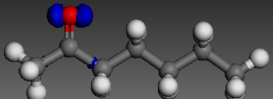
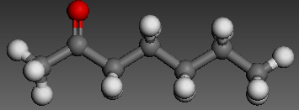
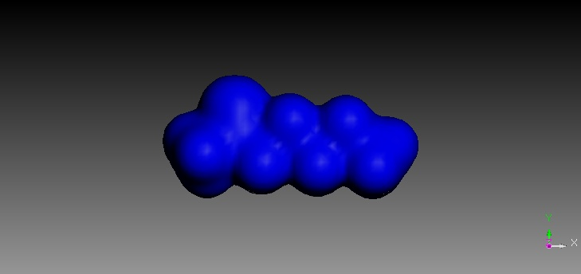

- Optimized structure b)Electron DENSITY

(a) (b) (c)
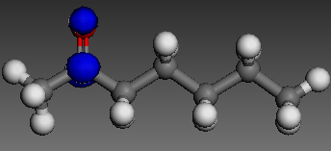
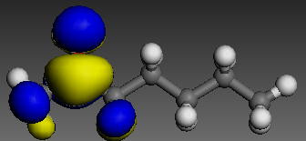
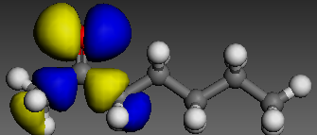

(d)
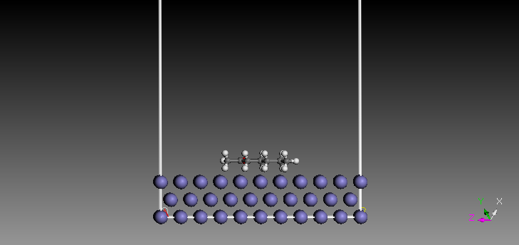
(e) (f)

(g)

Fig. 10 Electronic properties of 2-heptanone (HP) : (a) Optimized structure (b) Electron density, (c) Electrophilic f (-), (d) Nucleophilic f (+), (e) HOMO, (f) LUMO, (g) Molecular dynamics model of the adsorption of single molecule of HP on Fe (110) surface.
Atom legend: white = H; gray = C; red = O; purple = P. The blue and yellow iso-surfaces depict the electron density difference: the blue regions show electron accumulation while the yellow regions show electron loss.

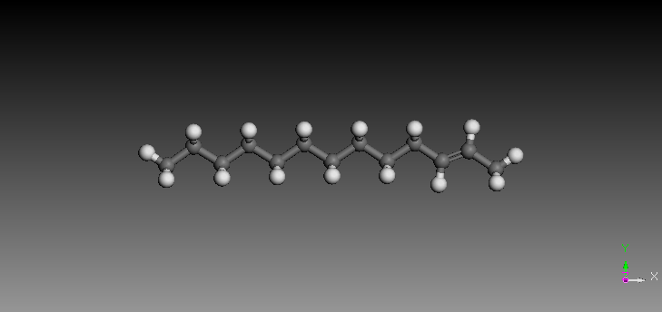
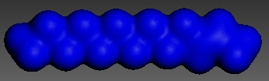
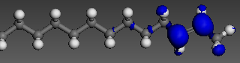

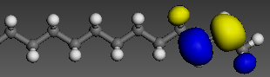
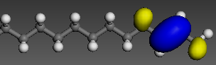
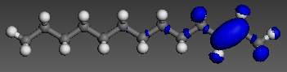
(a) (b) (c)

(d) (e) (f)

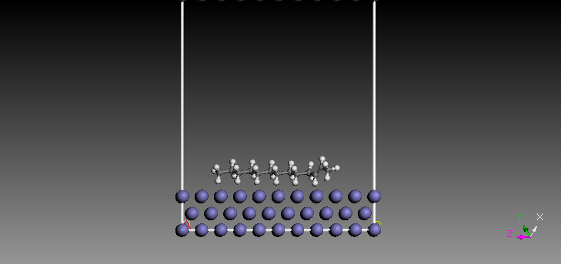

(g)

Fig. 11 Electronic properties of 2-tredecene (TC): (a) Optimized structure (b) Electron density, (c) Electrophilic f (-), (d) Nucleophilic f (+), (e) HOMO, (f) LUMO, (g) Molecular dynamics model of the adsorption of single molecule of TC on Fe (110) surface.
Atom legend: white = H; gray = C; red = O; purple = P. The blue and yellow surfaces depict the electron density difference: the blue regions show electron accumulation while the yellow regions show electron

3.8. Surface morphology
Scanning electron microphotographs of the surface of the mild steel specimens after immersion in 0.5 M H₂SO₄ and 1.0 M HCL solutions without and with DESE are shown in fig. 12 (a d). The surface morphology of the steel surfaces introduced into 0.5 M H₂SO₄ and 1.0 M HCL without and with 1.2gl⁻¹ concentration of dacryodes edulis seed extract after 24h were scrutinized using SEM, Fig.12 (a c) showed the corroded specimen immersed for 24h in both media, which related to the optimal corrosion rate of mild steel surface.Fig.12(b,d) represent the SEM morphology of the surface of mild steel specimen exposed for 24h in 0.5 M H₂SO₄ and 1.0 M HCL solutions containing 1.2gl⁻¹ concentrations of the DES extract. Surface examination of Fig.12 (b d) earlier mentioned indicated an impressive improvement on the corrosion hindrance of the surface of mild steel specimen. Close examination of Fig.12 C which represents the polished mild steel specimen, showed that the entire surface is plane [73].

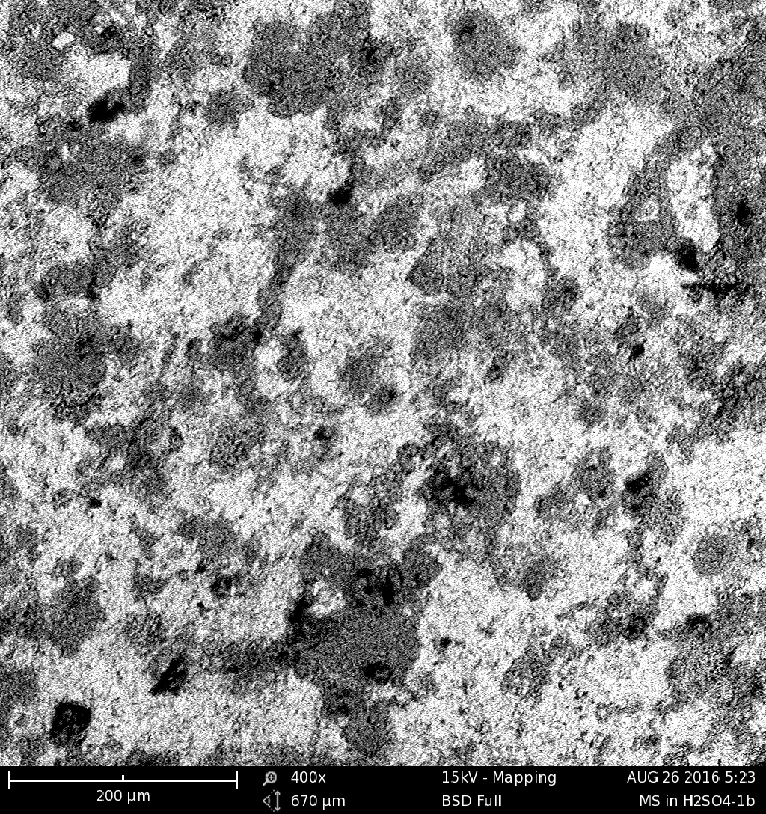
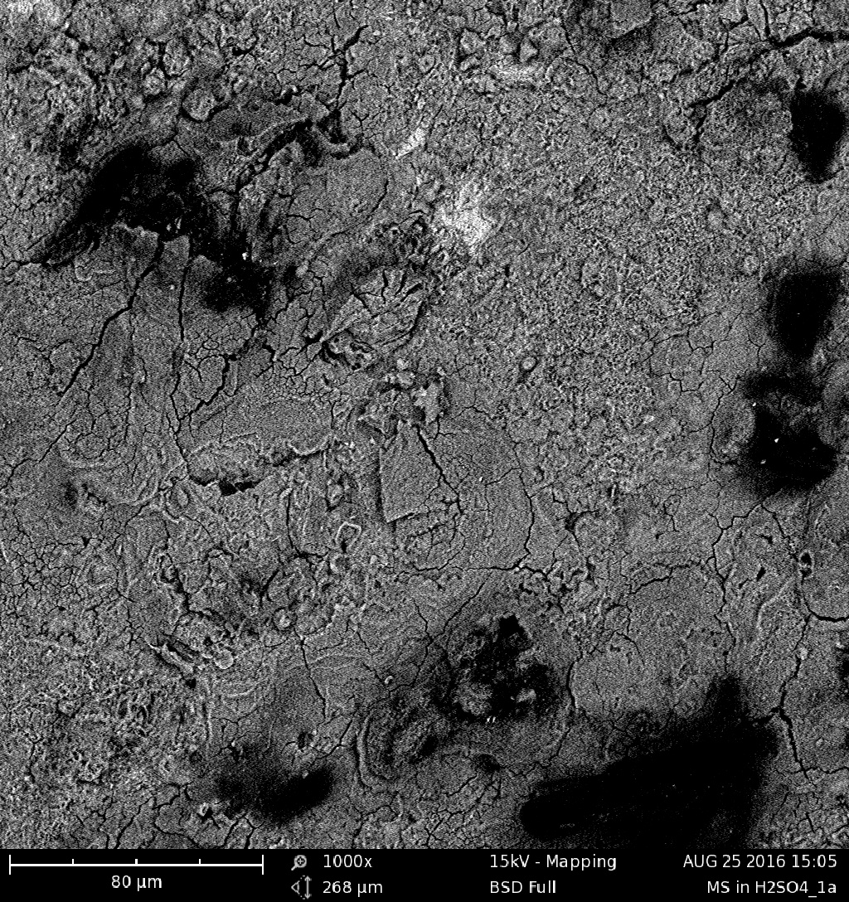

- (b)

- (b)

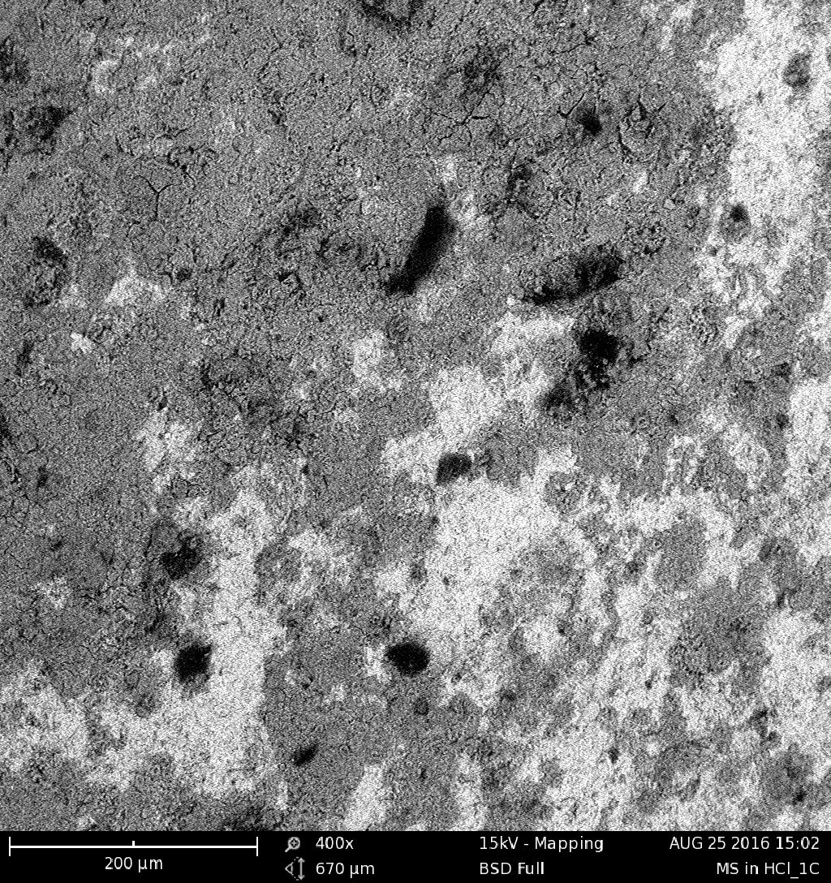
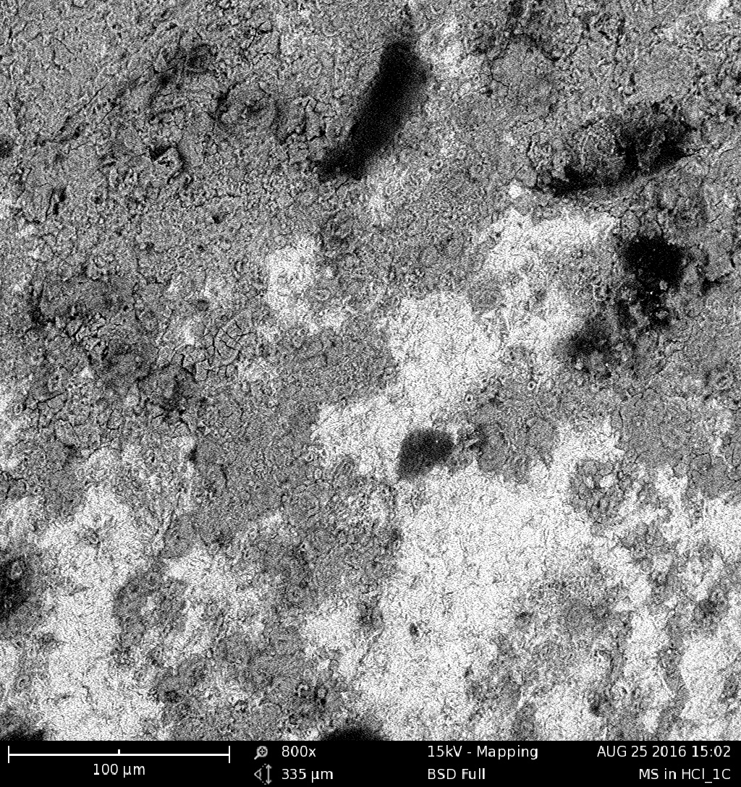

(c)
(d)
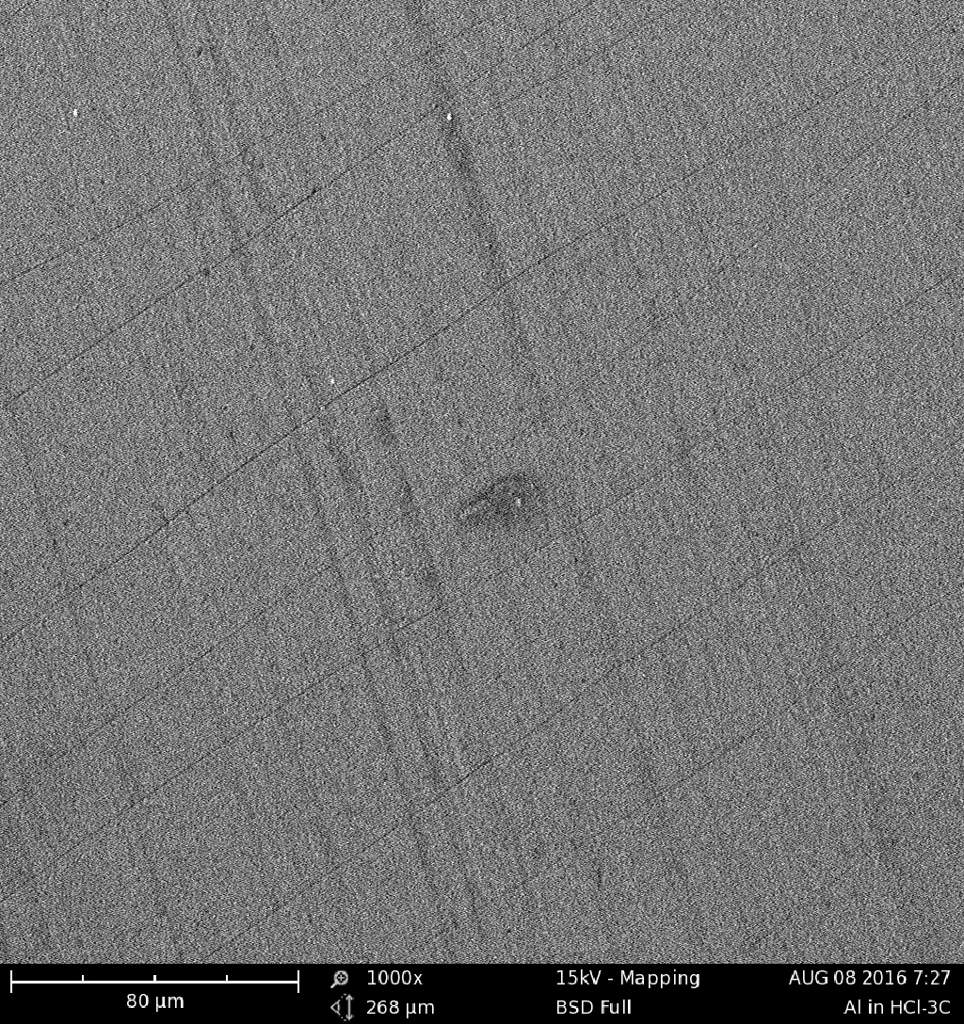

(e)

Fig. 12 Microphotograph obtained by optical microscope for surface morphology of mild steel corroded in : (a) H₂SO₄ (b) H₂SO₄ with 1000 gl⁻¹ inhibitor (c) HCl solution in absence of inhibitor. (d) HCl solution in the presence of 1000 gl⁻¹ inhibitor (e) Absence of both acidic solutions and inhibitor.

- Conclusion

Summarily, the aftereffects of the phytochemical analysis of the DES extract show ground-breaking inhibitive properties of phytocompounds that went about as great inhibitor for corrosion of mild steel in acidic solutions. The adsorption procedure of DES extract on the surface of steel is unconstrained, stable and pursued Langmuir adsorption isotherm. All the more thus, the seed extricate gave some security against setting corrosion of mild steel within the sight of forceful arrangements; and the dimension of acceptance expanded with consequent increment in concentrate focuses. Ideal hindrance efficiencies of 97.5 and 81.1 (%) were acquired at ideal inhibitor centralizations of 1.14 and 1.11 g^{-l}, 9.20 and 11.29 h and temperatures of 309.46 and 303.78 k in H₂SO₄ and HCl individually. DFT-based quantum chemical contemplations of parameters impacted with the dynamic atomic structures of 2-heptanone and 2-tredecene; the most dynamic constituents of DES extract specifically affirmed its corrosion defensive impact on ground of electron contributor acceptor communication. It likewise settled in a solid experimental terms, a connected restraint productivity of DES extricate molecules on steels
Acknowledgement

The authors sincerely acknowledged the staff and management of National Center for Energy Research and Development, University of Nigeria Nsukka (UNN). Isa Yakubu of National Research Center for Chemical Technology, Zaria, Nigeria. Our gratitude also goes to the staff and management of Kappas Biotechnology, Ibadan, Nigeria. However, we wish to state that no fund was received from any agency in the course of executing this research work.

Declaration

We wish to declare that the authors have no conflicting interest. We jointly carried out the research work and write the articles.

References

[1] Haldhar R , Prasad D, Saxena A 2018, Armoracia rusticana as sustainable and eco- friendly corrosion inhibitor for mild steel in 0.5 m sulphuric acid: experimental and theoretical investigations. Journal of Environmental Chemical Engineering 6 5230 - 5238

[2] Attabi S , Mokhtari M, Taibi Y, Abdel-Rahman I, Hafez B, Elmsellem H 2019 Electrochemical and Tribological Behavior of Surface-Treated Titanium Alloy Ti-6Al-4V, Journal of Bio-and Tribo-Corrosion 5 2

[3] Nnabuko O E, Momoh-Yaya H, Oguzie E E 2015 Theoretical & Experimental studies on the corrosion inhibition potentials of some Purines for Aluminium in 0.1 M HCl, Journal of Advance Research 6 203-217.
[4] Elmsellem H, Nacer H, Halaimia F, Aouniti A., Lakehal I, Chetouani A, Al-Deyab S. , Warad R. Touzani, Hammouti B 2014 Int. J. Electrochem. Science 9 5328.

[5] Narayana H, Praveen B M, Prasanna B M, Venkatesha T V, Abd Hamid S.B. 2014. Anthranilic Acid as corrosion inhibitor for mild steel in Hydrochloric Acid. Media. Procedia Material Science 5 712-718.

[6] Akalezi C O, .Oguzie E E, Ogukwe C E, Ejele A E 2015 Rothmannia Longiflora extract as corrosion inhibitor for mild steel in acidic media, Int. J. Ind. Chem. 6 273-284.

[7] Elmsellem H, El Ouadi Y, Mokhtari M, Bendaif H, Steli H, Aouniti A, Almehdi A M, Abdel-Rahman I, Kusuma H S, Hammouti B 2019 A natural antioxidant and an environmentally friendly inhibitor of mild steel corrosion: a commercial oil of basil (ocimum basilicum l, Journal of Chemical Technology and Metallurgy 4 742-749.

[8] Douche D, Elmsellem H, Anouar E H,etal 2018 Anti-corrosion performance of 8-hydroxyquinoline derivatives for mild steel in acidic medium:Gravimetric,electrochemical,DFTand molecular dynamics simulation investigations, Journal of Molecular Liquids
https://doi.org/10.1016/j.molliq.2020.113042

[9] Matjaz F, Jennifer J 2014 Application of corrosion inhibitors for steels in acidic media for the oil and gas industry, A review. Corrosion Science 86 17-41.

[10] Soltani N, Tavakkoli N, Khayatkashani M, Jalali M R and Mosavizade A 2012, Green approach to corrosion inhibition of 304 stainless steel in hydrochloric acid solution by the extract of Salvia oﬃcinalis roots, Corros. Sci., 62,122–135.
[11] Al-Otaibi M S, Al-Mayouf A M, Khan M, Mousa A A 2014 corrosion inhibitory action of some plant extracts on the corrosion of mild steel in acidic media, Arabian Journal of Chemistry 7 340-346.

[12] Elmsellem H, Karrouchi K, Aouniti A, Hammouti B, Radi S, Taoufik J, El Mahi B 2015 Der Pharma Chemica 7 237-245.
[13] Ji G, Anjum S, Sundaram S and Prakash R 2015, Musa paradisica peel extract as green corrosion inhibitor for mild steel in HCl solution, Corros. Sci., 90, 107–117.
[14] Deng S and Li X 2012, Inhibition by Jasminum nudiflorum Lindl. roots extract of the corrosion of aluminium in HCl solution, Corros. Sci., 64, 253–262.
[15] Njoku D I, Ukaga I, Ikenna O B,. Oguzie E E, Oguzie K L and Ibisi N 2016, Natural products for materials protection:Corrosion protection of aluminium in hydrochloric acid byKola nitida extract, J. Mol. Liq., 219, 417–424.

[16] Noor E A 2011, the impact of some factors on the inhibitory action of Radish fruits aqueous extract for mild steel corrosion in 1 M H2SO4 solution, Mater. Chem. Phys., 131, 160–169.
[17 ] Ezeugo J N O 2019, A design and an optimization of an eco-friendly extract for inhibition of mild steel corrosion in sulphuric acid media, J.Chem.Technol.and Metall.,54,810-825
[18] Ezeugo J O, Onukwuli O D, Ikebudu K O, Ezechukwu V C, Nwaeto L O 2019, Investigation of Akuama seed extract on corrosion inhibition of aluminium in hydrochloric acid pickling environment,Earthline Journal of Chemical Sciences,1, 115-138
[19] Quraishi M A, Singh A, Singh V K, Yadav D K and Singh A K 2010. Green approach to corrosion inhibition of mild steel in hydrochloric acid and sulphuric acid solutions by the extract of Murraya koenigii roots, Mater. Chem. Phys., 122, 114–122.

[20] Saxena A, Prasad D anD Haldhar R, 2017.Use of Butea monosperma extract as green corrosion inhibitor, Int. J. Electrochem. Sci., 12, 8793–8805
[21] Abd El-Aziz S F, Ahmed A N, Ayman Y E, Mohamed F 2014 Cinnamon Plant Extract as Corrosion Inhibitor for Steel Used In Waste Water Treatment Plants and its Biological Effect on Escherichia Coli, Int. Journal of the Korean Chemical Society 58 4.

[22] Sharma K S, Anjali P, Ime Bassey O 2015 Potential of Azadirachta Indica as a green corrosion inhibitor against mild steel, aluminium and tin: a review, Journal of Analytical Science and Technology 6 26.

[23] Hu Z, Meng Y, Ma X, Zhu H, Li J, Li C, Cau D experimental and theoretical studies of benzothiazole derivative as corrosion inhibitors for ca rbon steel in 1.0 M HCl. Corrosion Sci. 112 (2016) 563-575

[24] Thilagavathy P, Saratha R 2015 Mirabilis Jalapa flowers extract as corrosion inhibitor for the mild steel corrosion in 1M HCL, Journal of Applied Chemistry 8 30-35.

[25] Agiriga CE. 2019 characterizing protective action of dacryodes edulis on mild steel corrosion in different environment, J.Chem.Sci. Nigeria 44 4
[26] Peter A , Obot IB, sharma SK, 2015 Use of natural gums as green corrosion inhibitors : an overview , Int.J.Ind.Chemistry 6 153-164
[27] Bratte L , Mmereole FUC, Akpodiete OJ, Omoje SI 2010 The nutrient composition of seeds of the African pear and its implications for non-ruminant, pakistan Journal of nutrition 9 255-258
[28] Elmsellem H, Harit T, Aouniti A, Malek F, Riahi A, Chetouani A, Hammouti B 2015 Protection of Metals and Physical Chemistry of Surfaces, 51 873-884.

[29] Oguzie EE, Enenebeaku CK , Akalezi CO, Okoro SC, Ayuk AA, Ejike EN 2010 Adsorption and corrosion inhibiting effect of dacryodes edulis extract on low - carbon – steel corrosion in acidic media, J. Colloid .interf. 249 283-292
[30] Fouda A S, .Shalabi K, .Idress A A 2015 Ceratonia siliqua extract as a green corrosion inhibitor for copper and brass in nitric acid solutions. Green Chemistry Letters & Reviews, 8 3-4,17-29.

[31] Narayana H, Praveen B M, Prasanna B M, Venkatesha T V, .Abd Hamid S B 2014 Anthranilic Acid as corrosion inhibitor for mild steel in Hydrochloric Acid Media, Procedia Material Science 5 712-718.

[32] Shaily B M, Alabbas F M, Rahul B, Spear J R, Brajendra M, Olson D L, E.A.Kakpovbia E A 2014 Neem extract as an inhibitor for biocorrosion influenced by sulfate reducing bacteria: A preliminary investigation, Engineering Failure Analysis 36 92-103,
[33] Ezeugo J N O, Onukwuli O D, Omotioma M 2018 Inhibition of aluminium corrosion in 1.0 M HCl using Picralima nitida LEAF extract, Der Pharma Chemica, 10 SI 7-13.

[34] Onukwuli O D, Omotioma M 2016 Optimizations of the inhibition efficiency of mango extract as corrosion inhibitor of mild steel in 1.0M H₂SO₄ using response surface methodology, J. Chem. Tech. and Metallurgy 51 302-314.

[35] Ehsani A, Moshrefi R, Ahmadi M 2015 Electrochemical Investigation of Inhibitory of new synthesized3-(4-iodophenyl)-2-imino-2,3-Dihydrobenzo[d]Oxazol-5-yl4-Methyl-benzenesulfonate on corrosion of Stainless steel in Acidic Medium J. Electrochemical Sc. and Technol . 6 7-15
[36] Saxon A, Prasad D, Haldhar R, Singh G, Kumar A 2018 Use of Saraca ashoka extract as green corrosion inhibitor for mild steel in 0.5 M H₂SO₄, J. Molliq. Liquid, 258 89-97
[37] R Kumar, O S Yadav, G Singh 2017 electrochemical and surface characterization of a new eco- friendly corrosion inhibitor for mild steel in acidic media : a cumulative study , J . mol. Liq 237 413-427.
[38] Umoren S A,Uduok U M, Solomon M M, Udoh A P. 2016 corrosion in inhibition by leaves and stem extracts of sida acuta for mild steel in 1M H₂SO₄ solution investigated
by chemical and spectroscopic techniques. J. chem. 9 5209-5224.
[39] Hafez B, et al. 2019 "Environmentally friendly inhibitor of the corrosion of mild steel: Commercial oil of Eucalyptus", International Journal of Corrosion and Scale Inhibition 8 573-585.
[40] Umoren S A,Uduok U M, Solomon M M, Udoh A P. 2016 corrosion in inhibition by leaves and stem extracts of sida acuta for mild steel in , 1 M H₂SO₄ solution investigated
by chemical and spectroscopic techniques. J. Chem. 9 5209-5224.
[41] Murthy Z V P, Vijayaragavan K 2014 mild steel corrosion inhibition by acid extract of leaves of Hibiscus Sabdariffa as a green corrosion inhibitor and sorption behavior, Green Chemistry Letters and Reviews 7 209-219.

[ 42] Filali M, Elmsellem H, Hökelek T, El-Ghayoury A, Stetsiuk O, El Hadrami E M, Ben-Tama A 2019 Crystal structure, Hirshfeld surface analysis and corrosion inhibition study of 3, 6-bis (pyridin-2-yl)-4-{[(3aS, 5S, 5aR, 8aR, 8bS)-2, 2, 7, 7-tetramethyltetrahydro-5H-bis [1, 3] dioxolo [4, 5-b: 4′, 5′-d] pyran-5-yl) methoxy] methyl} pyridazine monohydrate, Acta Crystallographica Section E: Crystallographic Communications 75 1169-1174.

[43] Dwarika Prasad,Rajesh Haldhar, Akhil Saxena.Valeriana willichii 2018 root extract as a green and sustainable environmental : experimental and theoretical study. Mater. Chem. front. 2 1225-1237

[44] Ajayi A, Oderinde R A 2002. studies on the oil characteristics of Dacryodas edulis pulp and seed, Discov. Innov. 14 20-24

[45] Akhil Saxena Rajesh Haldhar, Dwarika Prasad 2018. Use of Asperagus racemosus extract as green corrosion inhibitor for mild steel 0.5 m H₂SO₄. J mater sci 53 8525-8535.

[46] Obasi N B B, Okolie N P 1993. Nutritional Constituents of the seed of the African Pear Dacryodes edulis. J. Food chem. 43 297-299
[47] Ezeugo J N O, Onukwuli O D, Omotioma M 2017. Optimization of corrosion inhibition of picralima nitida leaves extract as green corrosion inhibitor for zinc in 1.0 HCl. World News of Natural sci. 15 139-161
[48] Bentiss F, Gengenbre L,Lagrenee M , Lebrini M, Vezin H 2005. Electrochemical and quantum chemical studies of new thiadozele derivatives adsorption on mild steel in normal hydrochloric acid medium . corrosion Sci 47485505
[49]Bentiss F,Langrence M ,Lebrini M , Traisnel M ,Vezin H 2007. Experimental and theoretical study for corrosion inhibition of mild steel in normal hydrochloric acid solution by some new macrocychic polyther compounds. Corrosion Sci 49 2254-2269
[50] Casewit CJ ,colwell KS ,Rappe AK 1992. Journal of American Chemical Society 11410046
[51] Chidiebere MA, Oguzie EE ,Li,Liu,Ying ,Li ,wang F 2015.Adsorption and Corrosion inhibiting effect of ,riboflavin on 02235 mild steel corrosion inacidic environments.Materials chemistry and physics 15695-104
[52] Chidiebere MA, Oguzie EE ,Li,Liu,Ying ,Li ,wang F 2014.Corrosion inhibition of o₂235 mild steel in 0.5m H₂SO4 Solution by Phytic acid and Synergistic iodide additives . Industrial and Engineering Chemistry Research 770-779
[53] Martinez S ,Stagljar L 2003. Correlation between the molecular structure and the corrosion inhibition efficiency of chestnut tannin in acidic solutions .Theochem 640 167-174
[54] Anadebe VC ,Onukwuli OD ,Omotioma m, Okafor NA 2018.optimiation and electrochemical study on the control of mild steel corrosion in hydrochloric acid solution with bitter Kola leaf extract as inhibitor .S.Afr.J.Chem 71 51-61
[55] Jeetendra B,Preeti J, Valladares-Cisneros M.G, Cuevas Arteaga C, Murkta RB 2018.Quantum Chemical assessment of two natural compounds; Vasenesine and Vasicinone as green corrosion inhibitors. .inter .J. electro chemical sci 13 3200-3209
[56] Rosa V,Francisco F, Diaz-agomez A, Auron M 2018. Evaluation of Fuyi apple peel extract as a corrosion inhibitor for Carbon Steel in a Saline medium. Inter.J.electrochemical Sci 13 4139-4159
[57] Saqalli L,Galai M ,Gharda N, Sahranne M,Ghailane R,Touhami ME , Peres –ucchese Y,Souizi A, Habbadi N 2018. Corrosion inhibition of Carbon steel by anthraquinones derivatives in 1.0HCl: Electrochemical and quantum calculations.Int.J.Electrochemical Sci 13 5096-5119
[58] Ezeugo J O,,Onukwuli O D, Omotioma M 2018. Adsorption kinetics of picralima nitida leaf extract as a green corrosion inhibition for zinc in 0.5 M H₂SO₄. Equatorial Journal of Chemical Sciences 2 1-13

[59] Onukwuli O D, Ezeugo J O 2018. Plant extract as biodegradable inhibitor for zinc in dilute solution of sulphuric acid. World Scientific News 109 195-210.

[60] Khan P F, Shanthi V, Babu R K, Muralidharan S, Barik R C 2015. Effect of Benzotriazole on corrosion inhibition of copper under flow condition. J.Env.Chem.Eng.
[61]Akhil Saxena Rajesh Haldhar, Dwarika Prasad 2018.Use of Asperagus racemosus extract as green corrosion inhibitor for mild steel 0.5 M H₂SO₄. J.Mater sci 53 8525-8535.

[62] Abdel Rehim S S, Omar A H, Amin A M, Khaled FK 2008. The corrosion inhibition of low carbon steel in concentrated sulphuric acid solutions Part1: Chemical and electrochemical (AC & DC) studies. Corrosion Science 50 2258-2271

[63] Abdel-Rehim S S, Khaled K F, Al-Mobarak N A 2011.Corrosion Inhibition of Iron in Hydrochloric acid using pyrazole. Arabian Journal of Chemistry 4 333-337.

[64] Akalezi C O, Oguzie E E, Ogukwe C E, Ejele A E 2015. Rothmannia Longiflora extract as corrosion inhibitor for mild steel in acidic media. Int. J. Ind. Chem 6 273-284.

[65]Al-Otaibi M S, Al-Mayouf A M, Khan M, Mousa A A 2014. Corrosion Inhibitory action of some plant extracts on the corrosion of mild steel in acidic media. Arabian Journal of Chemistry. 7 340-346.

[66] Ameer M A, Fekry A M 2011.Corrosion Inhibition of mild steel by natural product compound. Progress in Organic Coating 71 343-349

[67] Aprael S Y, Anees A K, Rafal K W 2013. Apricot juice as green corrosion inhibitor of mild steel in phosphoric acid. Alexandria Engineering Journal 52 129-135

[68] Ating E I, Umoren S A,Udousoro I I, Ebenso E E, Udoh A P 2010. Leaves extract of Ananas Sativum as green corrosion inhibitor for aluminium in hydrochloric acid solutions. Green Chemistry Letters & Reviews 3 61-68

[69] Ayati N S, Khandandel S , Momeni M, Moayed M H, Davoodi A, Rahimizadeh M 2011. Inhibitive effect of synthesized 2-(3-pyridyl)-3,4-dihydro-4-quinazolinone as a corrosion inhibitor for mild steel in hydrochloric acid. Material Science & Physics 126 873-879.

[70] El-Etre A Y 2003. Inhibition of aluminium corrosion using Opuntia extract. Corrosion science 45 2455-2495

[71] Ezeugo J N O, Onukwuli O D, Omotioma M 2017.Optimization of Picralima nitida leaves extract as green corrosion inhibitor for Zinc in 1.0 M HCl. World News of Natural Science 15 139-161

[72] Fouda A S, Shalabi K, Idress A A 2015. Ceratonia siliqua extract as a green corrosion inhibitor for copper and brass in nitric acid solutions. Green Chemistry Letters & Reviews 8 17-29

[73] Ihebrodike M M, Nwandu M C, Okeoma K B, Nnanna L A, Chidiebere M A, Eze FC,2012. Experimental & theoretical assessment of the inhibiting action of Aspilia Africana extract on corrosion of aluminium alloy AA3003 in hydrochloric acid. J. Mater. Sci 47 2559-2572.

